NEWS RELEASE PH: 1 210-802-1434
HOLD PENDING RELEASE (January 11, 2021) Email: tquinn@efuel100.com
Different languages available on website (Japanese) Contact: Tom Quinn
E-FUEL CORPORATION
Website: www.efuel100.com
15511 TX HWY 71 W #110-141
AUSTIN, TEXAS 78738 U.S.A.

`Kyozetsu sa reta enerugī' no haigo ni aru hontō
no han'nin kikō hendō to sore o tomeru hōhō

Enerugī kakaku to sekiyu juyō wa, 1960-nendai kōhan irai mi rarenakatta
reberu made sagaru kanōsei ga arimasu

E - FuelCorporation no sōsetsu-shadearu ThomasQuinn ni your
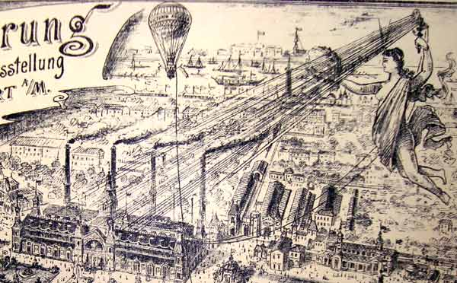
1882-Nen 9 tsuki 4-nichi, tōmasuejison wa, Manhattan no kin'yū machi ni aru pārusutorīto-eki ni aru sekai-hatsu no denryoku-mō shisutemu no suitchi o iremashita. Kono onaji jiki ni, Jon D rokkuferā wa tōyu to gasorin nenryō no seisan o kaishi shi, tsudzuite henrīfōdo no saisho no jidōsha seisan kōjō, soshite raito kyōdai ga kōkū sangyō o kikkusutāto shimashita. Hotondo no kagaku-sha wa, kono jidai ga watashitachi no genzai no shuyōna kikō hendō jōtai o hikiokoshita kanōsei ga aru koto ni dōi surudeshou. Tsutae rareru tokoro ni yoru to, kako 12-nenkan de, Beikokuoyobi kokusai-tekina tōshi-ka to seifu ga kōen suru josei-kin wa, kikō hendō o mukō ni suru tame ni saisei kanō enerugī gijutsu ni 3. 5 Chō-doru o tsuiyashimashita. Kikō hendō no panikku wa mata, enerugī hinkon o zōdai sa se, sekai o saranaru risuku ni sarashi, tekisetsuna kaiketsusaku o jinsoku ni mitsukete jisshi suru yō ni shite imasu.
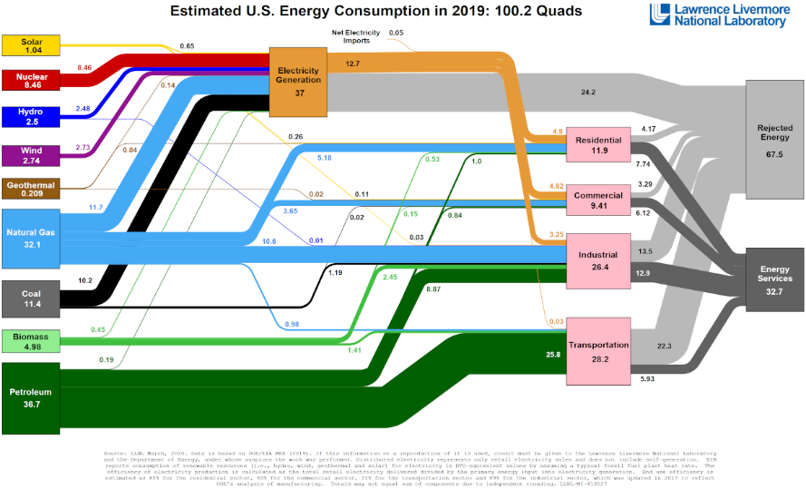
Watashi no saishin no sutātoappudearu E - FuelCorporationde wa, jissai no kikō hendō no mondai o tokutei shi, tadashī kaiketsusaku o jissō suru koto o sekkyokutekini tsuikyū shimashita. Watashitachi no kenkyū-chū Rinsetsu suru rōrensuribamoa kokuritsu kenkyūjo to Beikoku enerugī-shō no enerugī shōhi-ritsu chāto ni dekuwashimashita. Kono chāto ni wa,`kyohi sa reta enerugī' to iu taitoru no fuon'na kategori ga fukuma rete ori, 2tsu no ten de odorokasa remashita. Mazu, 2019-nen no reberu wa 67. 5-Pāsento to kisai sa rete imashita. Kore wa, tanso to onshitsu kōka gasu to tomoni taiki-chū ni haishutsu sa reta, shōhi sa retaga mi shiyō no Beikoku no enerugī no gōkei 100. 2 Chō kara tora reta shōkei no pāsentējidesu. Daini ni, nenkan no kyozetsu enerugī-ritsu wa kako 12-nenkan de 0. 3-Pāsento zōka shite ori, kore wa hoka no hōkoku sa rete iru kikō hendō kagaku dēta yori mo ōhaba ni waruidesu.
Kyohi sa remashita enerugī 67. 5-Pāsento

Kantan'niieba, 3-garon no nenryō o sharyō ni tōnyū shita baai, 1-garon dake ga sharin o kaiten sa seru tame no kikai-teki enerugī o teikyō shi, nokori no 2-garon wa rajiētā, tērupaipu, oyobi enjin no masatsu netsu ni yotte taiki-chū ni hōshutsu sa remasu. Denki jidōshade sae, batterī no jūden to hōden no saikuru-chū ni tsuneni enerugī o kyozetsu shi, batterī ga furuku naru ni tsurete kasoku shimasu. Darekaga nenryō no shiyō o yamerubekida to iu mae ni, chikyū-jō no subete no shōgyō-teki ni seizō sa reta seihin wa, seizō purosesu-chū ni chokusetsu matawa kansetsu-teki ni nenryō, tokuni saisei kanō enerugī o hitsuyō to shi, sore wa kawaranainode, fukanōda to iimasu. Higeki-tekina koto ni, kyozetsu sa reta enerugī wa, shakai ga mushi shite iru chikyū-jō de saidai no mikaihatsu no enerugī-gendesu. Kono hidoi 138-nen no shippai wa, sōgo sayō suru seibutsu no wakusei no ikimonogaku-teki komyuniti to sorera no butsuri-teki kankyō ni songai o ataemashita.

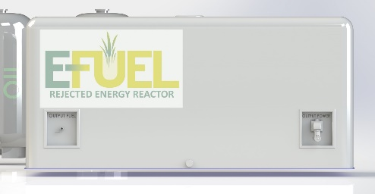
Soryūshon: E - Fuel wa, nenryō to hatsuden no ryōhō no purosesu o 1tsu no shisutemu ni fukumu chīsana genshiro o sakusei suru koto de, 138-nen mae no mondai o kaiketsu shi, kyohi sa reta enerugī o sai riyō dekiru yō ni shimashita. Kantan'niieba, genzai, nenryō to denryoku no ryōhō o seisei suru tame ni saidai kōritsu de jikkō shite iru toki ni 3-garon ga shiyō sa re, kako no nenryō shōhi-ryō to haishutsu-ryō ga 3-bun'no 2 sakugen sa remasu. E - Fuel wa, kono tekunorojīsoryūshon ga mottomo sekigyokutekideari, enerugī hinkon to tomoni kikō hendō o gyakuten sa seru tame no yuiitsu no jikkō kanōna sentakushidearu to kangaete imasu. Shōhisha to shōgyō kigyō wa, sekiyu juyō no kyūsokuna genshō to saisei kanō enerugī zairyō no hi seibutsu-tekina rotenbori ni kuwaete, 1960-nendai kōhan irai mi rarenakatta enerugī kakaku no ōhabana teika kara rieki o eru koto ga dekimasu.

E - Fuel ga tadashī kaiketsusaku o teikyō shita ima, yori ōkina mondai wa, chikyū no reikyaku o kaishi suru tame no paradaimushifuto o dono yō ni jissō suru ka to iu kotodesu. Kotae wa kantande, shihon to sono ōku ga, 50 oku-doru no ōdā de, chūō no sekiyu seiseijo, hi seibutsu-teki saisei kanō enerugī, oyobi denryoku-mō hendenjo no dankai-teki haishi o kaishi shimasu. Sekai ga kako 12-nenkan ni 3. 5 Chō-doru o tsuiyashi, Ainshutain ga kyōki to teigi shitadearou chikyū ondan-ka no haishutsu-ryō o nenkan 0. 3-Pāsento zōka sa seta koto o omoidashite kudasai. Sekai shimin ga gyōkai ni yōkyū shi, seifu ga hōkō o kaete, kikō hendō o tadashiku tomeru tame ni kyozetsu sa reta enerugī o ten'yō suru hōkō ni risettosuru-ji ga kimashita. 5 Chō-doru no enerugī sangyō ga genjō iji ni tadaina teikō o motarasu to yosō subekidesuga, sore ga watashitachi no unmei o teigi suru monode wa arimasen.

E - Fuel no saisho no dokuji no genshiro wa, denryoku, etanōru, suiso, oyobi tōyu jetto nenryō-yō no tei kosuto to tei tanso no seisan ni shōten o awasemasu. Riakutā no saizu to enerugī yōryō wa, kojin no ie, shōgyō biru, dētasentā, maikuroguriddo bunsan komyuniti, kyūyu oyobi jūden sutēshon, kōkū uchū oyobi kōkū nenryō, kaijō oyobi chijō kamotsu yusō gyōkai nado, habahiroi ofuguriddo no kokyaku ni sābisu o teikyō suru tame ni tekiō dekimasu. Nōgyō kakō sentā, furufirumento ryūtsū sentā, oyobi ōkibona seizō shisetsu.

E - Fuel Rejected Energy riakutā (RER) no seisan operēshon ni shikin o teikyō suru tame ni, E - Fuel wa, tokubetsu mokuteki shutoku kaisha (SPAC), kokusai-tekina kankyō ni yasashī pātonāshippu, oyobi GoFundMe o chōsa shite, chikyū no reikyaku o jinsoku ni kaishi suru tame no seisan katsudō no shikin chōtatsu o shien shite imasu. `STOPCLIMATECHANGE' no sapōto no shōsai ni tsuite wa, tōsha no u~ebu saito www. Efuel 100. Komu o goran kudasai.

