E-FUEL CONVERTS COMBUSTION ENGINE EXHAUST INTO OXYGEN

GAME CHANGER!

New line of Carbon Negative Power Generators and Ag Water Pumps set for 2022

E-Fuel Corporation Press Release
Paso Robles, CA USA
www.efuel100.com
Twitter: @efuel
Contact: +1-210-802-1434
JANUARY 2022
FOR IMMEDIATE RELEASED
Visit us at booth Q38
2022 WORLD AG EXPO®
February 8-10, 2022 • Tulare, CA

Today E-Fuel Corporation is announcing the world’s most advanced technology to combat
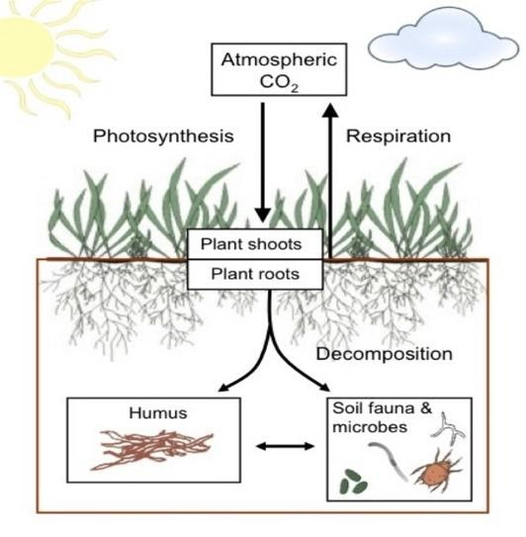
climate change and atmospheric carbon release through direct Sequestration of Combustion Exhaust into Soil (SCES), where carbon is converted in real-time versus stored. This exclusive zero cost process where CO₂ is diverted from the atmosphere and transferred directly into the Soil Carbon Pool (SCP) can provide the world a carbon negative E100 ethanol fuel. This process is primarily mediated by plants through photosynthesis, which then produces oxygen, when carbon is transferred to SCP. Global agricultural soils have lost up to 70% of their carbon which dangerously affects soil-to-atmosphere carbon balance and global food supply. Tom Quinn, E-Fuel CEO states: “If the E-Fuel SCES process is widely adopted, then humanity can dramatically change the dynamics of climate change and increase the world food supply.” When the E-Fuel SCES process is used, heated carbons in the soil increase water and fertilizer retention and cold weather resistance and shorten crop cycles, which overall provides more food to 8 billion people. When farmers, homeowners, or businesses purchase E-Fuel’s carbon negative E100 ethanol powered generators, or agricultural water pumps, E-Fuel will not charge for the SCES feature and will assist with installation. Homeowners can also enjoy SCES benefits by supercharging home gardens, trees, and lawns.
E-Fuel offers power and pump capacities in all size ranges.

E-Fuel’s SCP Experience:
In 2000, E-Fuel’s CTO, Floyd Butterfield, was hired by the owner of the downtown Paso Robles Inn to design and build a system to remove the rotten egg smell (caused by hydrogen sulfide gas) from the geothermal water produced by the Inn’s newly drilled geothermal well. The gas accompanying the geothermal water was mainly CO2, with very trace amounts of hydrogen sulfide. Floyd developed a system that would extract the CO2 and hydrogen sulfide gasses and direct them to a “biofilter” - essentially a planter where the gas was injected into the SCP root zone of plants. Amazingly, while removing the odors, the plants planted in the planter had growth rates and grew to sizes many times greater than similar plants outside the biofilter. In fact, the system was patented and the biofilter became a hotel attraction!

E-Fuel’s SCES system was built on that experience and can extract the CO2 in the engine exhaust and put it into irrigation water or directly into soil, in either case being directly used by plants, increasing growth rates, and allowing the plants to convert the CO2 to oxygen, through photosynthesis!

We can all breathe easier knowing we can finally win this fight!

